Basic Leadership Qualities
Constructive Feedback
Ephesians 4:15, 29 “But speaking the truth in love, may grow up into him in all things, which is the head, even Christ: … Let no corrupt communication proceed out of your mouth, but that which is good to the use of edifying, that it may minister grace unto the hearers.”
A person in a leadership role accepts the responsibility for helping others improve, and for self improvement. This process requires the leader to make observations and constructive suggestions, and to be able to accept constructive suggestions from other leaders or even followers.
There are many who feel that feedback is the same as criticism and is not a positive tool. Feedback can be positive if it is used in an effective manner. Feedback lets a person know how to improve his or her performance or what's wrong with an idea.
Good feedback can correct a problem when leaders learn to give the feedback in a positive manner. Practice will help you develop your skill in providing feedback so that group members will feel like “winners.” Guidelines to follow when providing feedback include:
- Corrective feedback should only be offered as a means of helping improve a group member's performance or ideas. It is important that the group member perceive the leader's intent as improvement.
- Constructive feedback or criticism directed toward an individual should never be given in front of other group members.
- Constructive feedback focuses on the problem not the person.
- Never offer feedback in an angry or punishing way.
- Feedback should include both the merits as well as the areas needing improvement in a person's performance or ideas.
- Feedback, both positive and corrective, should be specific.
- Constructive feedback is enhanced when the leader is an effective listener and takes time to secure the information needed to provide good feedback.
- As part of coaching and developing your team, your feedback should come with specific suggestions on how to improve the situation.
Let’s read each of these statements and determine if they adhere to the guidelines for constructive feedback.
- “Bob, I can't believe you did that. Do you realize you've ruined everything?”
- “Jane, your committee did an excellent job in planning this morning's breakfast meeting. I'd like to suggest that you visit with me before our next meeting because I have some ideas for improving attendance at our breakfast meetings.”
- “That's a great idea for an activity George. Would you consider starting the activity an hour earlier to allow our members to get home sooner in the evening?”
- “No Karen. That just won't work.”
- “I don't know why you can't do what I ask you to do. You always do things your way and not the way I tell you to do them. Why can't you listen?”
A good leader is always aware of what is happening in the organization, and how members of the organization are feeling about its progress. When organization members are active, they need consistent and frequent feedback from their leaders.
One final note. A good leader is able to accept feedback as well as give it. If the group shares their concerns, a good leader listens and considers what the group members have to say. If a higher authority makes suggestions, the good leader listens carefully and attempts to make corrections. Remember, the good of the organization should be everyone's concern. Using feedback effectively can help an organization achieve its goals.

Radical Candor Paradigm
From the book Radical Candor by Kim Scott

Manipulative insincerity
These individuals are sneaky. They are motivated by personal gain. They don’t care about others. They pretend to. And they definitely don’t challenge.

Ruinous empathy
These folks want to care about others, but they care in the wrong way. For example, the executive who praises a team member in public, without knowing that doing so may make other team members feel bad.

Obnoxious aggression
These people say what’s on their mind. But they don’t care about other people’s feelings. Obnoxious aggressors believe that telling the truth trumps people’s feelings.

Radical candor
Radical candor is about confronting others … in a way where they have the other person’s best interests at heart. It’s about being candid in a helpful way, without any hidden or personal agendas.
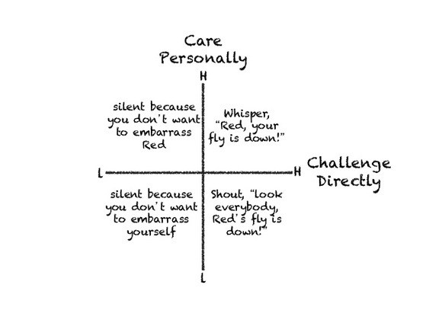

Basic Leadership Qualities
Constructive Feedback
